Team J Project Proposal

I. Team Information
- Project Name: The Rosalind Franklin Story
- Group Members: Le Nguyen Nguyen Thao, 2699063; Lee Yoona, 2421060; Lee Seoyun, 2490053; Zhang Yulin, 2494118; Greta Schmedes, IES26575
II. Project Overview
- Format: This project is a storytelling puzzle game where players become a female scientist called Rosalind Franklin to recreate her discoveries and scientific contributions.
- Game Mechanism: The core gameplay is inspired by the game “Storyteller” on Netflix, where we let players arrange characters, equipment, actions, and items inside comic panels to build story scenes. There will be 3 other mechanisms in the game to make the player feel more engaged:
- Cutscenes: after finishing a chapter, an animated cutscene that recaps the post-chapter while providing broader historical and institutional context. There will be light interactions while watching them.
- Scientific literacy in items: educational content will be added through interactive features and visual art. There will be pairs between the game's visuals and real photographs of Franklin's setup unlocked as achievements. Moreover, when the player moves the cursor to an item, there will be notes about the use of the items appeared.
- Mini games: There will be times when the player fails to finish a frame because they are missing an item and an instructor redirects them to a room puzzle mini-game, where players can inspect the laboratory to search for the missing items.
- Medium justification:
- This genre has its core fans.
The main reference for our game, Storyteller, has gained over 10 million players. These two games (left picture) are titles with similar mechanics to our game. The rating is stable and positive¹. Moreover, the number of wishlists and concurrent players peak records are approximately 2% and 8% each, showing rates above the median². Also, on YouTube, we can see how The Storyteller-liked games can go viral³.
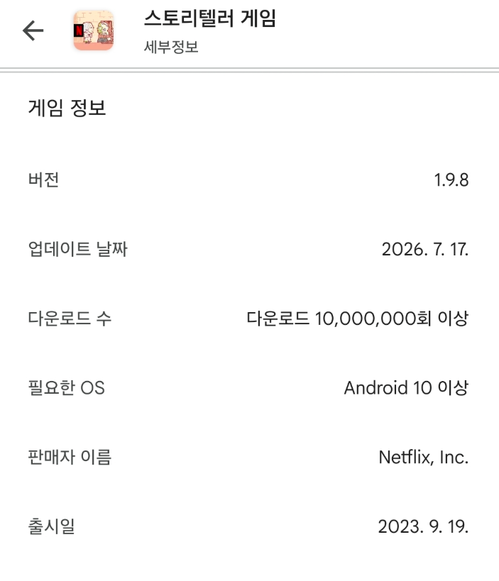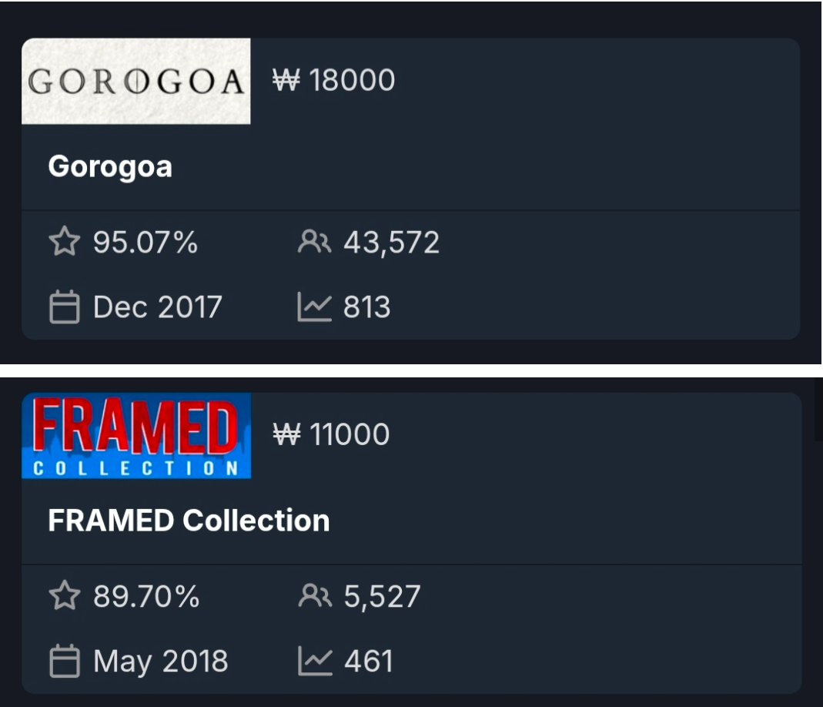
- Studies on game‑based and puzzle‑based learning in science show that interactive games lead to significantly better learning outcomes and engagement than video or traditional instruction.
- Research on interactive vs. passive learning finds that active formats have much higher retention, around 25-60%, than passive video, around 8-10%, because they force learners to retrieve information and get immediate feedback⁴.
- Work on interactive digital storytelling reports higher retention and deeper comprehension when learners actively construct the story⁵.
- The panel‑based storytelling mechanic creates multiple paths and failure/success variations, which research links to higher engagement and better understanding of complex processes^{4,5}.
- The lab‑room mini‑games improve learning gains, especially when players lead the problem‑solving rather than just being told what to do^{4,5}.
- Combining game visuals with real photos of Franklin’s lab and a collectable lab notebook turns the experience into an interactive museum‑lab, which serious‑games research associates with stronger knowledge retention and emotional connection to the subject⁶.

III. The Communication Problem:

Many people know about DNA and the double helix, and have also heard about the names Watson and Crick. However, Franklin’s contribution, especially Photo 51, is often less well known. Because Watson and Crick received the Nobel Prize after Franklin had already passed away, popular media tend to credit two male scientists for the entire discovery⁷. This underrated the leadership of female scientists from history, therefore reinforcing gender biases in STEM.

Moreover, media often portrays science as sudden moments where scientists suddenly come up with ideas, which overlooks the laboratory work and repeated trials behind true discoveries.

Our game addresses this gap by letting players experience Franklin's actual experimental trials and restoring her rightful place in science history.

IV. Target Audience & Communication Goals
- Target Audience: The target audience is teens and 20-year-olds among indie game fans.
Why is this audience specifically?
- Indie game players expect indie developers to make creative and bold attempts. They care about the idea, not the illustration quality of AAA games⁷, making them the most receptive group for an experimental biographical puzzle game.
- Students in this age group are currently learning about genetics and DNA structure in school. However, standard textbooks still mostly credit Watson and Crick, while Rosalind Franklin's hard work and Photo 51 are rarely taught in detail^{(China textbooks), 8}.
- Communication Goals:
- Equity and Historical Recognition: Franklin’s contributions are more widely known and help players understand how her research contributed to the development of our understanding of DNA, making the picture of female scientists more familiar to the public.
- Attitude Outcome: Teenagers without a professional scientific background can find science and history more interesting and accessible through gameplay and storytelling, leading to them being excited to explore and learn more about science themselves later on.
- Knowledge Outcome: The public’s science literacy may develop by understanding the brief process of doing genetic or biological science, the importance of Franklin’s contributions to science and society, and knowing about Franklin’s findings themselves.

V. Tasks Distribution

Tasks Distribution: Link
- Thao: Core game design, main engine programming, mini-game coding, final web publishing.
- Yoona: All pixel art assets and gameplay storyboards.
- Yulin: Full story plot, dialogue scripts, tutorials, Cutscene 1 illustrations.
- Seoyun: Backgrounds, research item assets, sound effects, and background music.
- Greta: Mini-game puzzle mechanics, Cutscene 2 illustrations, cover, logo art.
- Team: Concept brainstorming, testing, bug fixing.

Production Timeline
- September: Finalize the story concept and initial character designs.
- October: Finish Gameplay storyboards, game design mechanics, pixel art assets, audio sourcing.
- November: Finalize full dialogue scripts, main mechanics and mini-games, lab backgrounds and animated cutscene videos, testing and bug fixing.
- Early December: Finalize polish and publish the playable web game.
VI. Source
- 🧩 Puzzle Games on Steam · SteamDB
- GameDiscoverCo: The State of Steam Wishlist Conversions (2024–2025)
- Enhancing self-directed learning in science education: the Impact of puzzle-solving games and video-based materials on understanding the origin of electricity
- Why Interactive E-Learning Outperforms Passive Video-Based Learning
- Serious Games in Science Education: A Systematic Bibliometric and Content Analysis
- This puzzle game gets TRICKY - @heyKipp
- 80 Level Research: Heavy Indie Gamers, Who Are They?
- The story behind Photograph 51

